**Logging in spotify**

1. **Open login page of spotify.**

* URL of spotify is (https://accounts.spotify.com/login).

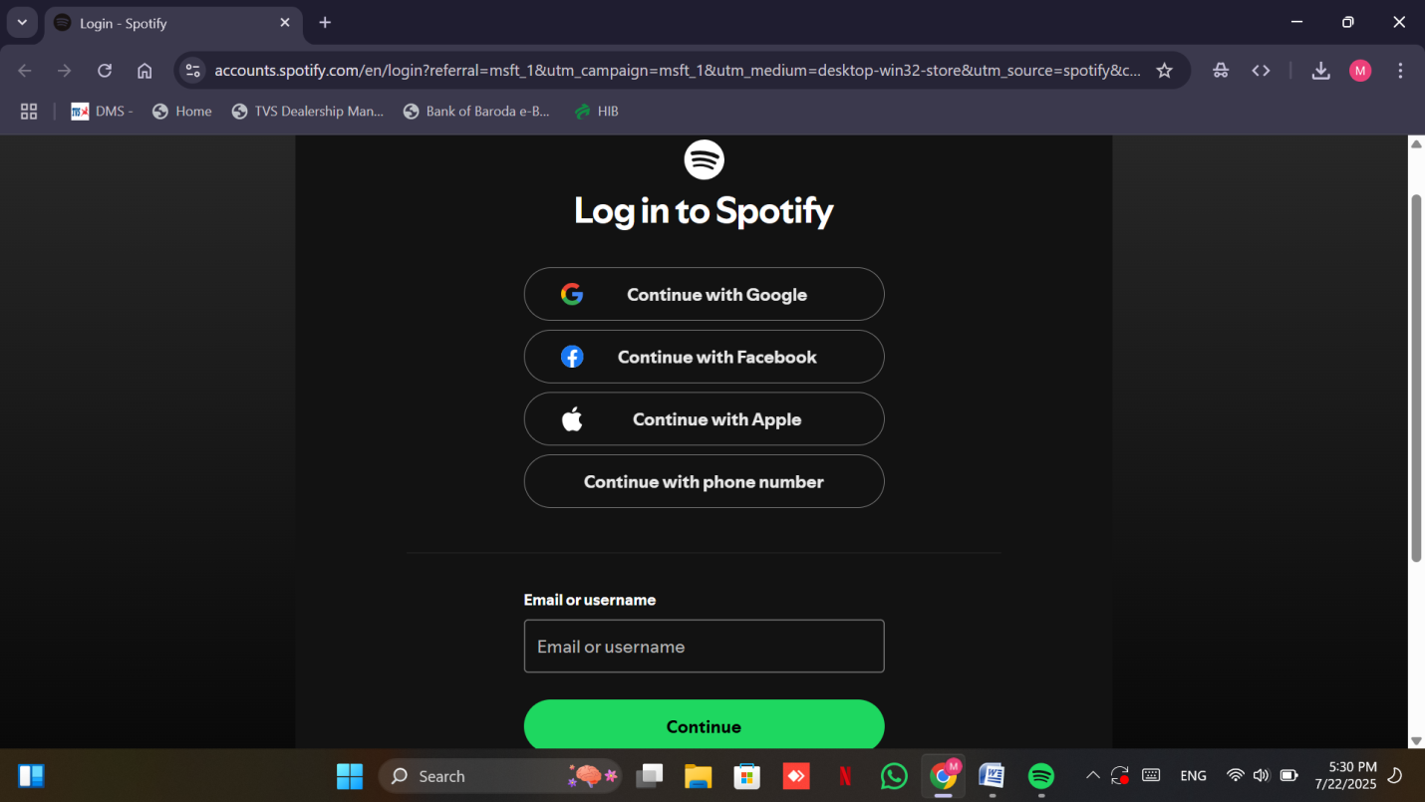

1. **Login procedure**

* Enter username or email id.

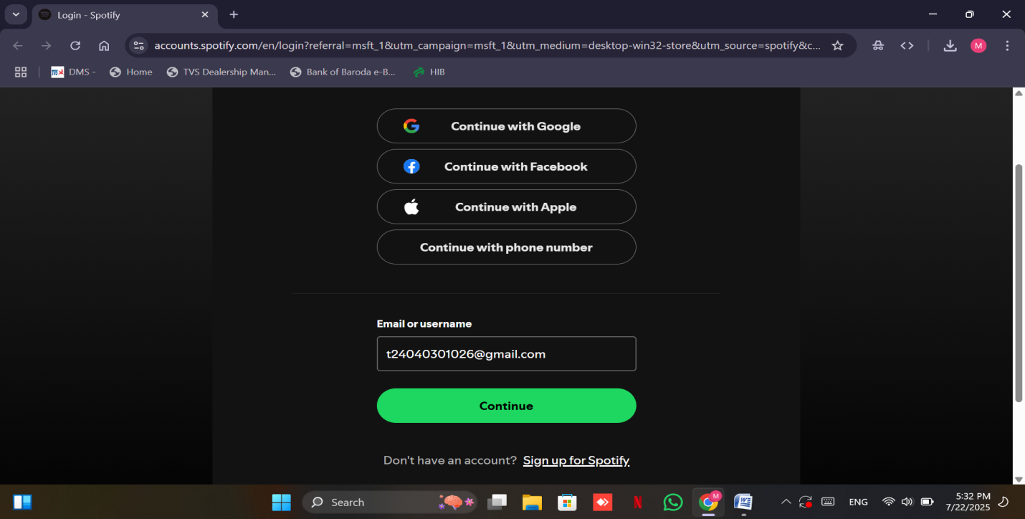

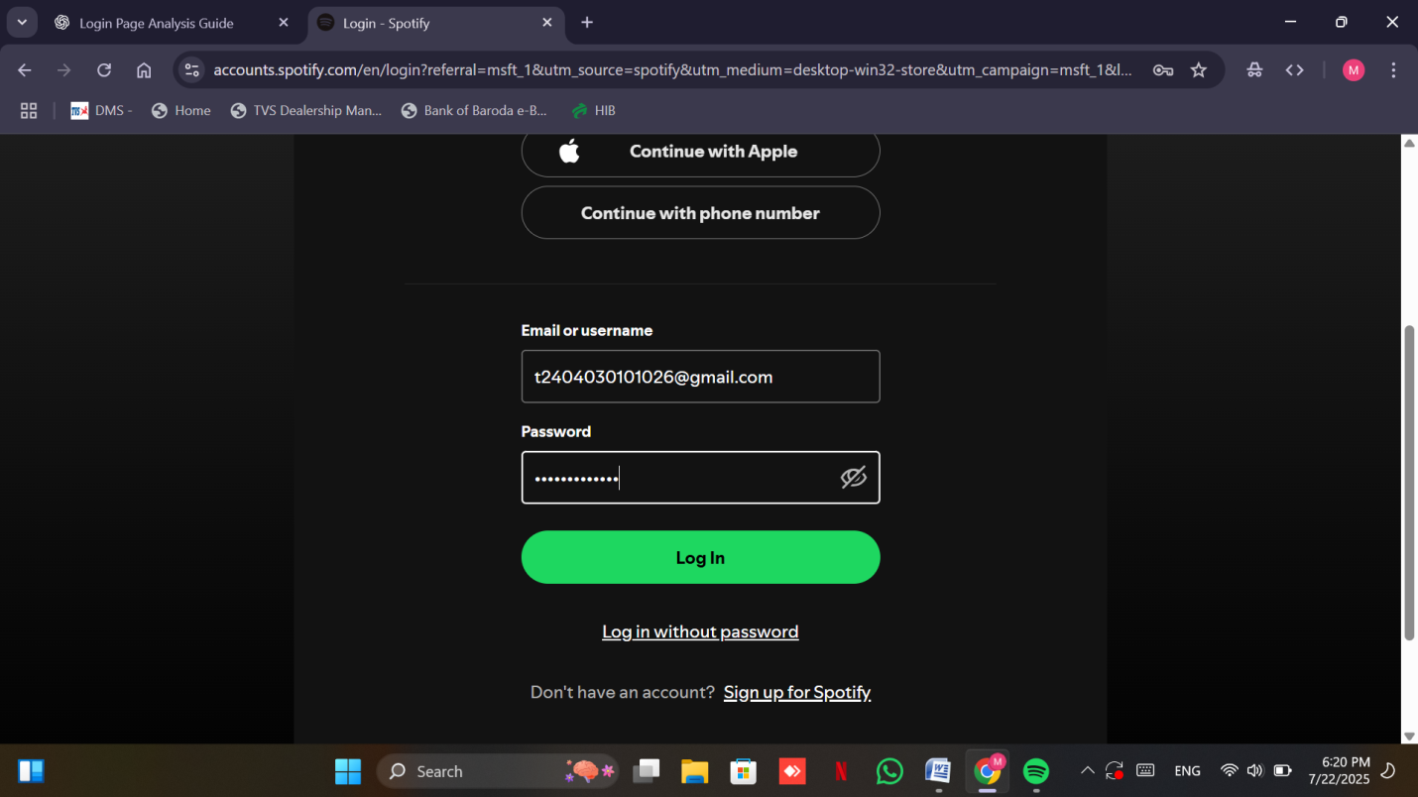

* Enter the password.
* Then click the login button to proceed.
* In the end spotify home page will be opened.

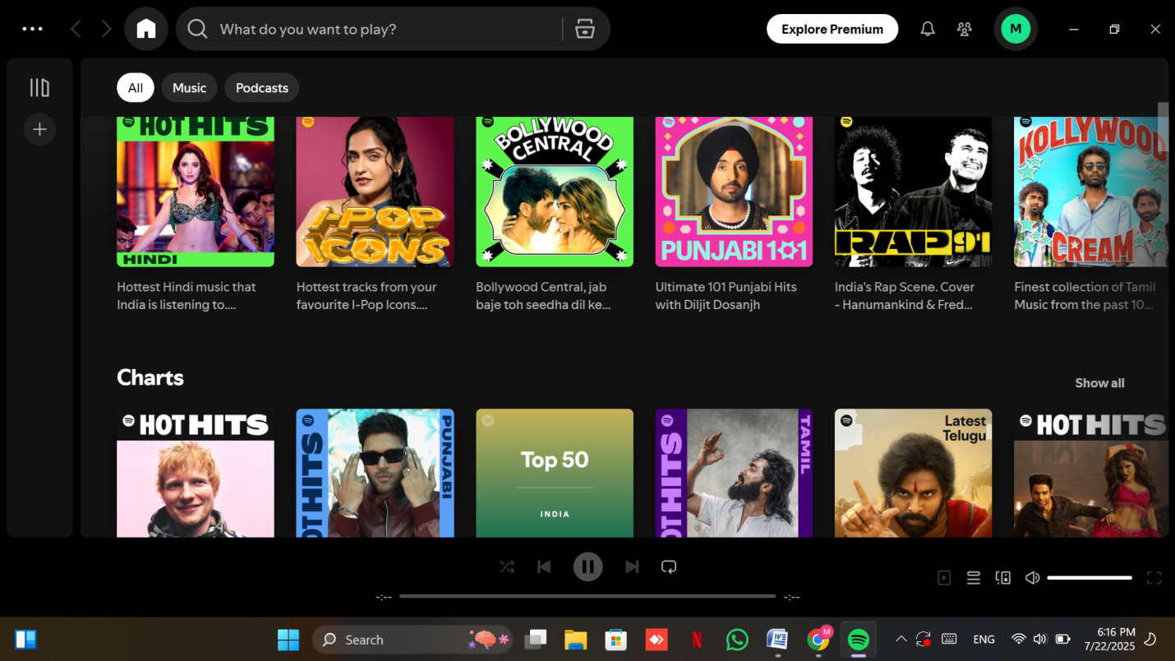

**Button functionality and click response**

1. **Spotify uses two main login-related buttons**:

* Login page access button.
* Submit/login button.

Both buttons are responsive and function on the first click.

1. **Validation features**

* For email/username validation form does not accept invalid or incomplete id.

For example entering incorrect format of email like picture given below.

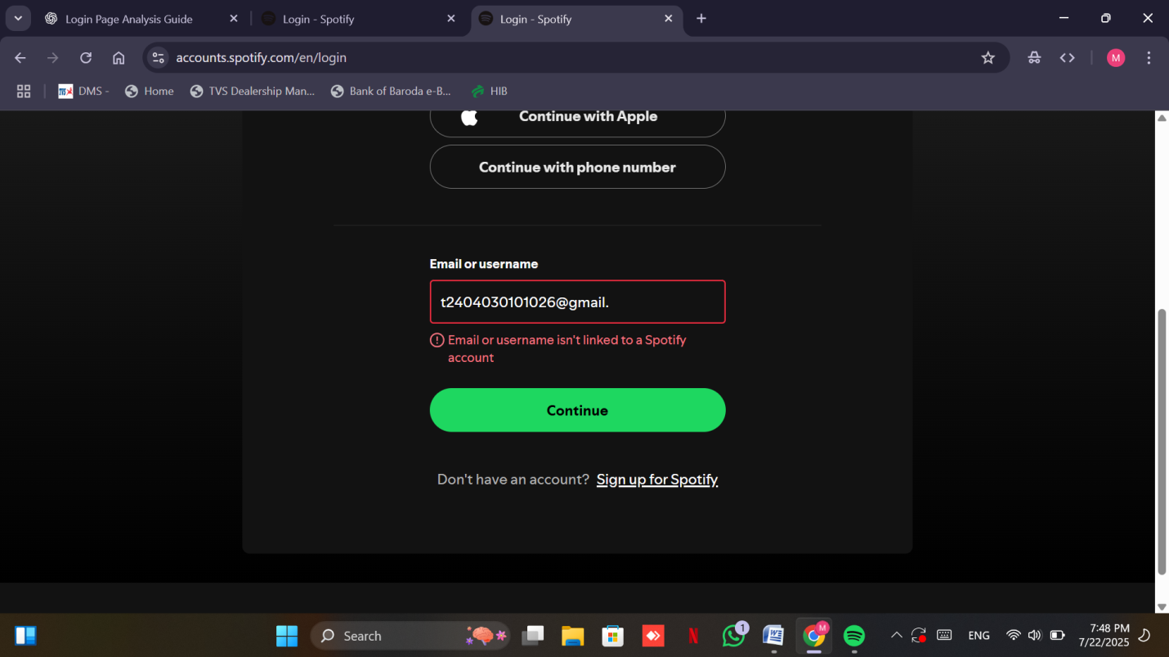

1. **Password Validation**

* Entering an incorrect password triggers a visible **error message**.
* The system does not allow login with wrong credentials.

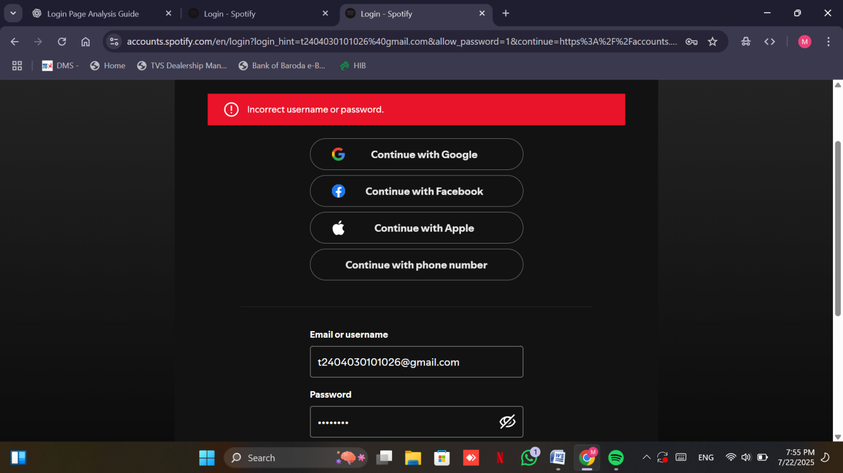

#### ****Additional Security Option****

#### If users forget their password, Spotify offers a **verification code** system.

* + A code is sent to the registered email ID to complete the login process
  + This adds a layer of security and user-friendliness. 